**Ammar raza**

**21p-8004**

**Question1 (1):**

n=10

for i in range(1,n+1):

for k in range(1,i+1):

print("*",end='')

print()

**output(1):**

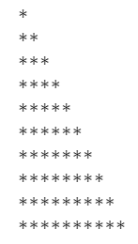

**Question1(2):**

for i in range(11,0,-1):

for k in range(i):

print("*",end='')

print()

**Output(2):**

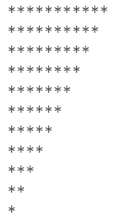

**Question1(3):**

m=10

for i in range(0,m):

for k in range(i):

print(" ",end='')

for j in range (min,i,-1):

print("*",end='')

print()

**Output(3):**

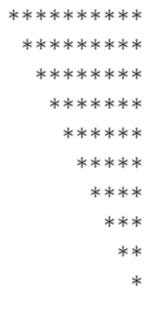

**Question1(4):**

m=10

for i in range(0,m):

for k in range(min,i,-1):

print(" ",end='')

for j in range (i):

print("*",end='')

print()

**Output(4):**

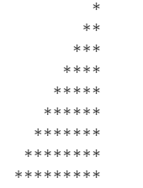

**Question2:**

n=input("user enter symbol : ")

s=5

for i in range(1,s+1):

for k in range(1,i+1):

print(n,end='')

print()

for i in range(4,0,-1):

for k in range(i):

print(n,end='')

print()

**Output1:**

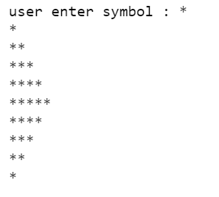

**Output2:**

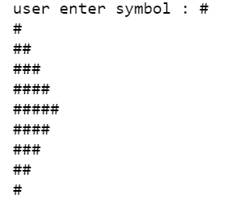

**Question 3:**

counter=1

for b in range(0,1):

while b<3:

a=input("Enter the name of student "+str(counter)+":")

x=int(input("Enter score 1: "))

y=int(input("Enter score 2: "))

z=int(input("Enter score 3: "))

c=x+y+z

avg=c/3

b+=1

counter+=1

print("Name: ",a)

avg = "{:.2f}".format(avg)

print("Average: ",avg)

**Output:**

